# Road Segmentation

## Abstract & Introduction

* Parler de l’évolutuon des capteurs qui nous vaons sur les sateltes qui nous permettent de prendre des photos en HD
* importance of road extraction from satellite images arises from the fact that it greatly enhances the efficiency of map generation and thus can be a big help in car navigations systems or any emergency (rescue) system that needs instant maps.
* This is a challenging domain compared to extraction from aerial images as satellite images are noisy and of lower resolution.
* The satellite images can be represented as raster images and digital raster images can be classified as portrayals of scenes, with imperfect renditions of objects. Imperfections in an image result from the imaging system, signal noise, atmospheric scatter and shadows.
* Since the first American land observation satellite launched in 1972, all kinds of technologies applied to the RS image processing have developed rapidly, including image compression, transmission, classification, fusion and un- derstanding. All of those high resolution RS images such as IKonos, QuickBird, WorldView and GeoEye create a quick and economical way to access the newly acquired geographic information, and lay a very important basis for the further applications of RS technology.

Methods

* SEMI-AUTOMATIC : Il y a une method semi-automatique ou l’humain montre ce qui est la route et puis ensuite l’algorithm retrouve la route 🡪 This saves time and human effort in extracting roads from images. The drawback is that manual intervention is needed initially to perform the computation.
* **Vectorization Approach to Road Extraction:** A novel automatic road network detection approach based on the combination of segmentation and vectorization is explained, which includes three main steps: (i) the image is segmented to roughly identify the road network regions; (ii) the decision making and continuity procedure to correctly detect the roads and (iii) the Vectorization step to identify the line segments or curved segments which represent the roads segment.
* Fig.4. Automated Road Extraction Flow Diagram
* 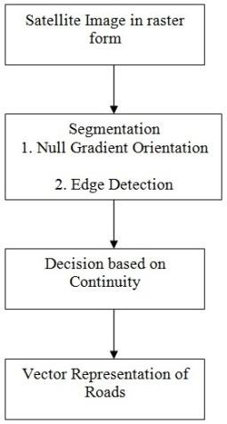In the vectorization approach of road extraction no seed points have to be given. The method adopted is to identify the road segments which are represented as **continuous line segments as the road could be of any arbitrary shape.** The start and end points of each line segment is identified and the road segments in the image are correctly extracted. The first stage is to identify the road network regions using segmentation. Then a decision making and continuity procedure is being performed in order to correctly detect the road.
* The first stage of the automatic method is to classify the road from the given satellite image using segmentation which consist of two stages namely the Null Gradient Orientation method and the Edge Detection method. The Null Gradient Orientation method finds out the gradient at all pixels and then the eigen transform is being performed on the tensor and the result is such that there will be two eigen values and two eigen vectors. The method is to choose those pixels for which at least one eigen value has a minimum which corresponds to a road. And also the Eigen vector corresponding to minimum Eigen value gives the direction of road. The next stage is the edge detection using the Canny Operator which identifies the edges which shows superior results compared to other edge detection methods. Also two threshold values are fine tuned so that the small connected elements are rejected and only the large connected areas are chosen. In the second stage the task is to detect the line segments and the Hough Transform is being used to detect the line segments. The final stage is the vectorization step where the road segments are clearly identified from the High Resolution Satellite Image.

*4.1. Image Segmentation*

In computer vision, segmentation refers to the process of partitioning a digital image into multiple segments (sets of pixels, also known as super-pixels). The goal of segmentation is to simplify and/or change the representation of an image into something that is more meaningful and easier to analyze. Image segmentation is typically used to locate objects and boundaries (lines, curves, etc.) in images. More precisely, image segmentation is the process of assigning a label to every pixel in an image such that pixels with the same label share certain visual characteristics. The result of image segmentation is a set of segments that collectively cover the entire image, or a set of contours extracted from the image (see edge detection). Each of the pixels in a region is similar with respect to some characteristic or computed property, such as color, intensity, or texture. Adjacent regions are significantly different with respect to the same characteristics.

*4.2 Null Gradient Orientation*

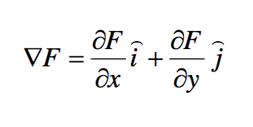The Gradient of a function of two variables F(x,y) can be defined The above equation can be collected as a collection of vectors pointing in the direction of increasing values of F. The numerical gradients (differences) can be computed for functions with any 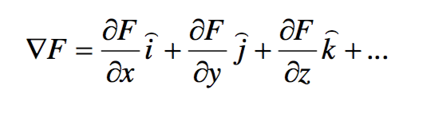number of variables. For a Function of N variables F(x,y,z,...) the gradient can be computed as

(2)

The description for the above equations can be given as: FX = gradient (F) where F is a vector returns the one- dimensional numerical gradient of F. FX corresponds to F/ x, the differences in the x (column) direction. FY corresponds to F/ y, the differences in the y (row) direction. The spacing between points in each direction is assumed to be one. [FX,FY,FZ,...] = gradient(F) where F has N dimensions returns the N components of the gradient of F. There are two ways to control the spacing between values in F:

A single spacing value, h, specifies the spacing between points in every direction. N spacing values (h1,h2,...) specifies the spacing for each dimension of F. Scalar spacing parameters specify a constant spacing for each dimension. Vector parameters specify the coordinates of the values along corresponding dimensions of F. In this case, the length of the vector must match the size of the corresponding dimension. In vector calculus, the gradient of a scalar field is a vector field which points in the direction of the greatest rate of increase of the scalar field and whose magnitude is the greatest rate of change. The property of Road is that there is continuity in one direction. So the method adopted is to find the Gradient at all pixels. The Gradient is then represented as a Tensor. Eigen Transforms are being performed on the Tensor which consists of two eigen values and two eigen vectors. The idea is to choose those pixels for which at-least one eigen value has a minimum value which corresponds to a road. Also the eigen vector corresponding to minimum eigen value gives the direction of road.

*4.3 Edge Detection*

Edge detection is a fundamental tool in image processing and computer vision, particularly in the areas of feature detection and feature extraction, which aim at identifying points in a digital image at which the image brightness changes sharply or more formally has discontinuities. In the ideal case, the result of applying an edge detector to an image may lead to a set of connected curves that indicate the boundaries of objects, the boundaries of surface markings as well as curves that correspond to discontinuities in surface orientation. Thus, applying an edge detection algorithm to an image may significantly reduce the amount of data to be processed and may therefore filter out information that may be regarded as less relevant, while preserving the important structural properties of an image. If the edge detection step is successful, the subsequent task of interpreting the information contents in the original image may therefore be substantially simplified. However, it is not always possible to obtain such ideal edges from real life images of moderate complexity. Edges extracted from non-trivial images are often hampered by fragmentation, meaning that the edge curves are not connected, missing edge segments as well as false edges not corresponding to interesting phenomena in the image – thus complicating the subsequent task of interpreting the image data.

The edge detection algorithm being employed is the Canny Edge Detection Algorithm which consists of multi stages.

The algorithm runs in 5 separate steps:

* Smoothing: Blurring of the image to remove noise.
* Finding gradients: The edges should be marked where the gradients of the image has large magnitudes.
* Non-maximum suppression: Only local maxima should be marked as edges.
* Double thresholding: Potential edges are determined by thresholding.
* Edge tracking by hysteresis: Final edges are determined by suppressing all edges that are not connected to a very  certain (strong) edge.  *4.4 Decision Making based on Continuity*  A lot of edges are proved not to be roads through the procedure of edge detection. Therefore road following or tracking is one of the most important steps in road detection. The major goal of road tracking is to eliminate road- like but non-road pixels. Hough Transforms are being used to perform this step. In automated analysis of digital images, a sub-problem often arises of detecting simple shapes, such as straight lines, circles or ellipses. In many cases an edge detector can be used as a pre-processing stage to obtain image points or image pixels that are on the desired curve in the image space. Due to imperfections in either the image data or the edge detector, however, there may be missing points or pixels on the desired curves as well as spatial deviations between the ideal line/circle/ellipse and the noisy edge points as they are obtained from the edge detector. For these reasons, it is often non-trivial to group the extracted edge features to an appropriate set of lines, circles or ellipses. The purpose of the Hough transform is to address this problem by making it possible to perform groupings of edge points into object candidates by performing an explicit voting procedure over a set of parameterized image objects.  *4.5 Vector Representation of Roads*

Vector graphics is the use of geometrical primitives such as points, lines, curves, and shapes or polygon(s), which are all based on mathematical equations, to represent images in computer graphics. Vector graphics formats are complementary to raster graphics, which is the representation of images as an array of pixels, as it is typically used for the representation of photographic images. Computer displays are made up from grids of small rectangular cells called pixels. The picture is built up from these cells. The smaller and closer the cells are together, the better the quality of the image, but the bigger the file needed to store the data. If the number of pixels is kept constant, the size of each pixel will grow and the image becomes grainy (pixellated) when magnified, as the resolution of the eye enables it to pick out individual pixels.

Vector graphics files store the lines, shapes and colours that make up an image as mathematical formulae. A vector graphics program uses these mathematical formulae to construct the screen image, building the best quality image possible, given the screen resolution. The mathematical formulae determine where the dots that make up the image should be placed for the best results when displaying the image. Since these formulae can produce an image scalable to any size and detail, the quality of the image is limited only by the resolution of the display, and the file size of vector data generating the image stays the same. Printing the image to paper will usually give a sharper, higher resolution output than printing it to the screen but can use exactly the same vector data file.

2.1. Road features

* In general, we have to make an image enhancement so as to extract useful information from a RS image. A road in a RS image appears as elongated geometric features with slowly changed gray values. As described by Vosselman and Knecht (1995), the road features in an image are summarized from four different aspects. Based on their description, the road features in an image can be concluded as follows:
* (1) Geometric features
* A road has a stripe feature its width does not suddenly vary much and its length is not as short as its width. The ratio between length and width is very large. The road junctions usually can be presented as the signs of “T”, “Y”, or “þ”.
* (2) Photometric features
* Photometric features are also known as radiation features. It means there are two obvious road edge lines, and the edge gradient is larger. Meanwhile, the gray values or colors of roads are relatively consistent and change slowly, but they are
* very different from those of the neighboring non-road areas such as trees and buildings, etc.
* (3) Topological features
* Generally, a road has intersections. The road network is not suddenly interrupted.
* (4) Functional features
* A road has specific functions in the real world. In order to realize those functions, it must have some constraint conditions.
* (5) Texture features
* Textures in an image have the regional characteristics, which are a kind of visual features to reflect the homogeneity phenomenon in the image. It has nothing to do with the color and intensity information. The essence of texture features is to find the spatial distribution of pixel gray levels in the neighborhood (Wang et al., 2014).
* Different road features in an image have different proper- ties for road extraction. Geometric features have the direct relationships with the road shapes. Photometric features are close to the road gray levels or colors. Topological features and functional features are relatively simple but hard to apply in real applications.
* In practice, many road extraction methods use multiple road features rather than only one feature. However, due to the influence of illumination, shadow and occlusion, a road in an image does not have all the features mentioned above, which makes it difficult to extract road from a RS image.
* 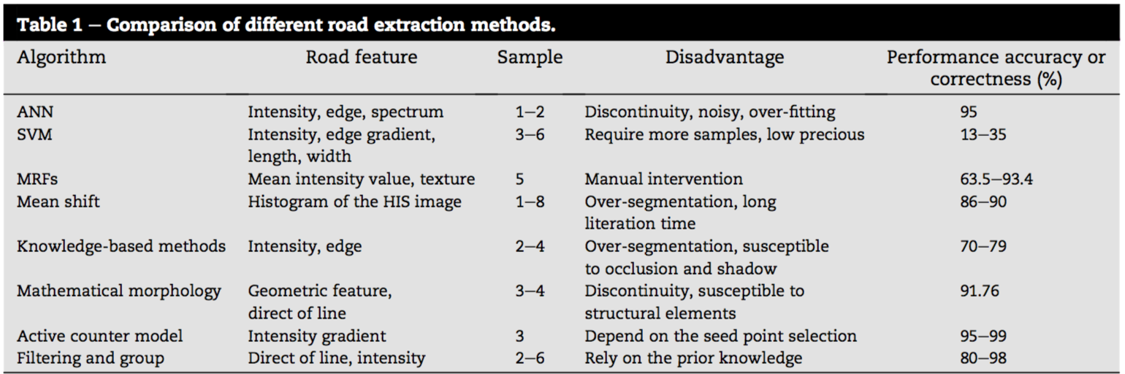
* source: A-review-of-road-extraction-from_2016_Journal-of-Traffic-and-Transportation-.pdf

## Conclusion

* In the automatic method of road extraction no seed points have to be given. The method automatically identifies the road segments in a high resolution satellite image where the output is highly dependent on the image. This method is more suited in rural areas than in urban areas where man-made objects are less and it is possible to detect the roads more easily. Through the segmentation, decision making based on continuity and vectorization procedure the raster satellite images can be converted to vector representation and it is possible to extract roads from satellite images. In the case of complex road structures and also in the case of occlusions the semi automated method gave better results than an automated method. The significance of the automated method is that human labour can be minimized to a very large extent. For a real large scale road extraction work, a combination of both methods is being proposed. The first stage employs the utility of the automatic method where the road segments are identified and for identifying the missing parts of the road the semi automatic method is being employed. The combination of both the methods will save time as well as reduce human labour to a very large extent.